 | Curriculum Vitae _ Omar A. Imran .
Objective .
To earn a position of responsibility in the fields of Electrical Engineering (electronic engineering, electrical energy, Renewable energy), that enables me to utilize my skills and theoretical expertise to deal with electrical energy and electronics problems. In addition, my postgraduate degrees enable me to university teaching and working.
 |  |  | 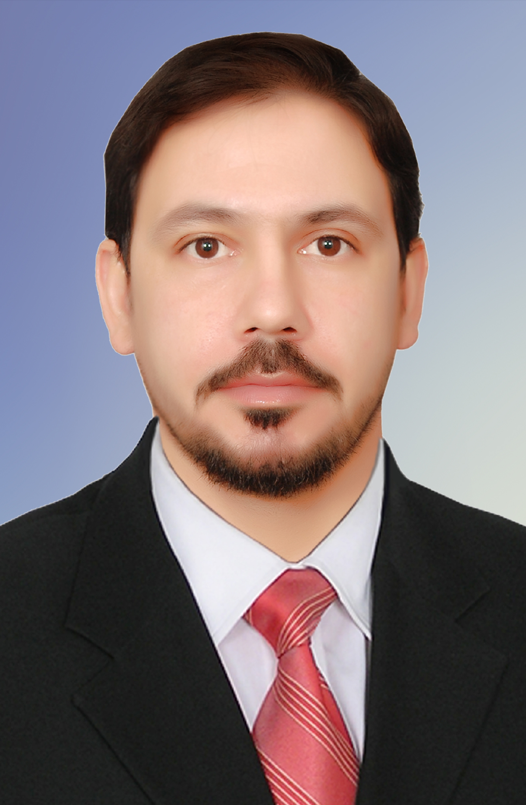
 | Personal Information | .
 | Academic degree: | Lecturer
 | Birth Date & Place: | July, 5, 1983 – Iraq
 | Nationality:  h index | Iraqi  3
 | Email: | omarimran53@yahoo.com, omarimran53@engineering.uodiyala.edu.iq
 | Website: | www.uodiyala.edu.iq
 | License: | Iraqi International Driving License.
 | Postal address: | College of Engineering, Diyala University, Ba’qubah City, Diyala Governorate,
 |  | ZIP 32001, Iraq.
Professional Strength and Skills .

- Professional strength and skills for participation and prestige of responsibility in the fields of electrical engineering (electrical foundations, electrical power and electronic engineering in digital and analogue circuit design and also interested in modern software that enable me to utilize my skills and theoretical experience to serve university teaching and work.
- Also interested in renewable energy, especially in the fields of solar cells and wind power

Educational Qualifications .
• | Ms. C. Electrical Energy | 2012 - 2013 | Belgorod Government Technology University Russia's Federal
• | B.Sc. Electronic Engineering | 2005 -2006 | College of Engineering – Diyala
 | University-Iraq. (English Curriculum).

Training and Courses .

- Computer Programming Course – University of Diyala.
- Methods of Teaching Course – University of Diyala.

Languages .
• |  | English: |  | Written and spoken (good)
• |  | Russia |  | Written and spoken (Very good)
 | Arabic: |  | Mother tongue.
Employment History (Academic & Technical) .
Diyala University – College of Engineering |  |  |  |  |  | (2007 – till now)
Location: Diyala – Iraq

Academic degree: Assist. Lect .

Description: Teaching Fundamental of Electrical Engineering and Programming and Programming Lab.
for the first and second stages and Engineering And Digital Electronics for the second stage.

Software .

- MatLab.
- Visual Basic.
- Qbasic.
- C++.
- Proteus.
- Arduino.
- Electronics Workbench.
- Multisim.
- Microsoft Office, Word, Excel, Power Point.

Published Research Papers .
No | Title of research | Journal name | Publisher or hosting | ISSN
1 | Voltage Control of Buck Converter-Based Ant Colony Optimization for Self-Regulating Power Supplies | Journal of Engineering and Applied Sciences.  2018. Volume 13 / Issue: 12 / Page No.: 4463-4467 | Scopus | 1816 – 948X
2 | Design and Implementation of Micro Controller Propeller Displays | Journal of Engineering and Applied Sciences.  2018. Volume 13 / Issue: 15 / Page No.: 6220-6224 | Scopus | 1816 – 948X
3 | A novel hybrid error detection and correction method using VHDL | International Journal of Engineering & Technology.  2018. Volume 7 / Issue: 4 / Page No.: 3048 - 3053 | Scopus | 3793 - 3798
4 | Speed control of universal motor | International Journal of Power Electronics and Drive System (IJPEDS).  2019. Volume 10 / Issue: 1 / 41 - 47 :.Page No | Scopus | 2088-8694
5 | Executing Work Principle Star/Delta Starter in Motor Systems using Allen-Bradley PLC | Journal of Engineering and Applied Sciences.  2019. Volume 14 / Issue: 6 / Page No.: 1805-1812 | Scopus | 1816 – 948X
6 | The Boiler Pipes Failure in Power Plants (South of Baghdad Station) | Journal of Engineering and Applied Sciences.  2019. Volume 14 / Issue: 7 / Page No.: 2187-2194 | Scopus | 1816 – 948X
7 | Аutomаtіϲ ԍenerаtіon control based wһale орtimіzation αlgorithm | International Journal of Electrical and Computer Engineering.  2019. Volume 6 / Issue: 9/ Page No.: 4516-4523 | Scopus | 2088-8708
8 | Implementation of El-Gamal algorithm for speech signals encryption and decryption | Procedia Computer Science 167 (2020).  Page No. 1028–1037 | Scopus | 1877-0509
9 | Design and simulation of high frequency colpitts oscillator based on BJT amplifier | International Journal of Electrical and Computer Engineering (IJECE)/  Vol. 10, No. 1, February 2020, pp. 160~170 | Scopus | 2088-8708

For more information visit the following link: .
SCOPUS | https://www.scopus.com/authid/detail.uri?authorId=57204525577
Research Gate | https://www.researchgate.net/profile/Omar_Imran
Acadimeca.edu | https://uodiyala.academia.edu/OmarAImran
Google Scholar | https://scholar.google.com/citations?user=5b6b8N4AAAAJ&hl=ar
Publons  | https://publons.com/author/1219684/omar-a-imran#profile
ORCID | http://orcid.org/0000-0002-0842-7258
Mendeley | https://www.mendeley.com/profiles/omar-a-imran/

